AI ASSISTANT CODING
LAB-02
Name : V . Shiva Harsha
Roll No : 2303A5375
Batch No : 33

Lab 2: Exploring Additional AI Coding Tools beyond Copilot – Google Gemini (Colab) and Cursor AI

Task – 1 : Refactoring Odd/Even Logic (List Version)
Scenario: You are improving legacy code.
The given legacy program calculates the sum of odd and even numbers in a list. The code needs to be improved for better readability and efficiency using AI tools.
Prompt Used :
Write a program to calculate the sum of odd and even numbers in a list,
Refactor this Python code to improve readability and efficiency.
Original Code :
def sum_odd_even(numbers: list[int]) -> tuple[int, int]:
even_sum = 0
odd_sum = 0
for num in numbers:
if num % 2 == 0:
even_sum += num
else:
odd_sum += num
return even_sum, odd_sum
my_list = [1, 2, 3, 4, 5, 6, 7, 8, 9, 10]
even_sum, odd_sum = sum_odd_even(my_list)
print(f"List: {my_list}")
print(f"Sum of even numbers: {even_sum}")
print(f"Sum of odd numbers: {odd_sum}")

AI-Refactored Code :
def sum_odd_even(numbers: list[int]) -> tuple[int, int]:
"""
Calculates the sum of even and odd numbers in a list.

Args:
numbers: A list of integers.

Returns:
A tuple containing (even_sum, odd_sum).
"""
even_sum = sum(num for num in numbers if num % 2 == 0)
odd_sum = sum(num for num in numbers if num % 2 != 0)
return even_sum, odd_sum

# Example usage:
my_list = [1, 2, 3, 4, 5, 6, 7, 8, 9, 10]
even_sum, odd_sum = sum_odd_even(my_list)

print(f"List: {my_list}")
print(f"Sum of even numbers: {even_sum}")
print(f"Sum of odd numbers: {odd_sum}")
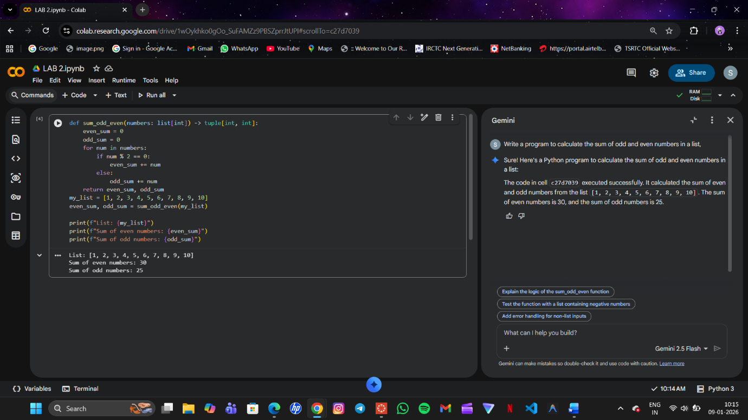
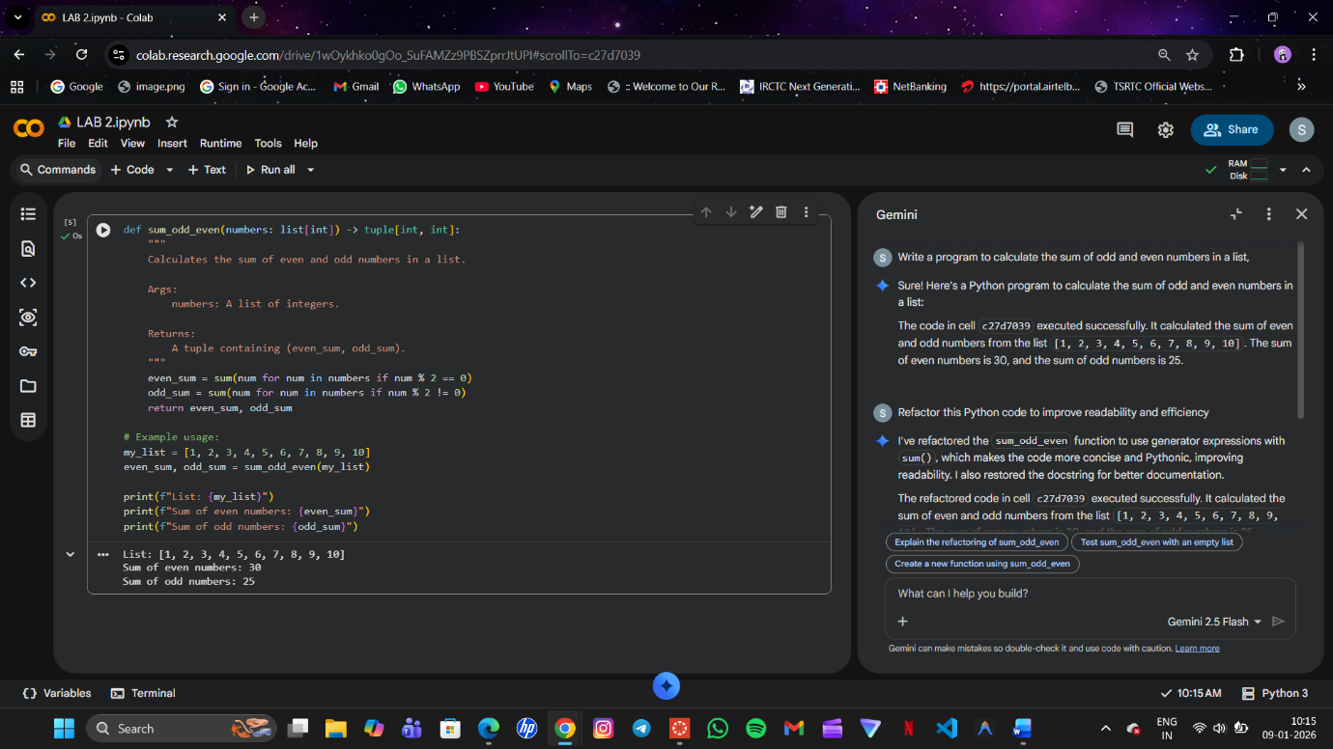
Explanation :
The refactored code reduces the number of variables and uses Python’s built-in sum() function. It improves readability, reduces code length, and enhances maintainability. The logic is clearer and easier to modify.

Task 2: Area Calculation Explanation (Gemini)
Scenario
This task helps onboard a junior developer by explaining a function that calculates areas of different shapes.
Prompt Used :
Write a Python function to calculate area of circle, rectangle, and triangle and explain the code
import math

def calculate_area(shape: str, **kwargs) -> float:
"""
Calculates the area of different geometric shapes.

Args:
shape (str): The type of shape ('circle', 'rectangle', 'triangle').
**kwargs: Keyword arguments for the dimensions of the shape:
- For 'circle': 'radius' (float)
- For 'rectangle': 'length' (float), 'width' (float)
- For 'triangle': 'base' (float), 'height' (float)

Returns:
float: The calculated area of the shape.

Raises:
ValueError: If an unsupported shape is provided or required dimensions are missing.
"""
if shape.lower() == 'circle':
if 'radius' in kwargs:
radius = kwargs['radius']
return math.pi * radius**2
else:
raise ValueError("For 'circle', 'radius' is required.")
elif shape.lower() == 'rectangle':
if 'length' in kwargs and 'width' in kwargs:
length = kwargs['length']
width = kwargs['width']
return length * width
else:
raise ValueError("For 'rectangle', 'length' and 'width' are required.")
elif shape.lower() == 'triangle':
if 'base' in kwargs and 'height' in kwargs:
base = kwargs['base']
height = kwargs['height']
return 0.5 * base * height
else:
raise ValueError("For 'triangle', 'base' and 'height' are required.")
else:
raise ValueError("Unsupported shape. Choose from 'circle', 'rectangle', or 'triangle'.")

# Example usage:
print(f"Area of circle (radius=5): {calculate_area('circle', radius=5):.2f}")
print(f"Area of rectangle (length=4, width=6): {calculate_area('rectangle', length=4, width=6):.2f}")
print(f"Area of triangle (base=7, height=3): {calculate_area('triangle', base=7, height=3):.2f}")

# Example of handling an error (uncomment to test):
# try:
# print(calculate_area('square', side=5))
# except ValueError as e:
# print(f"Error: {e}")
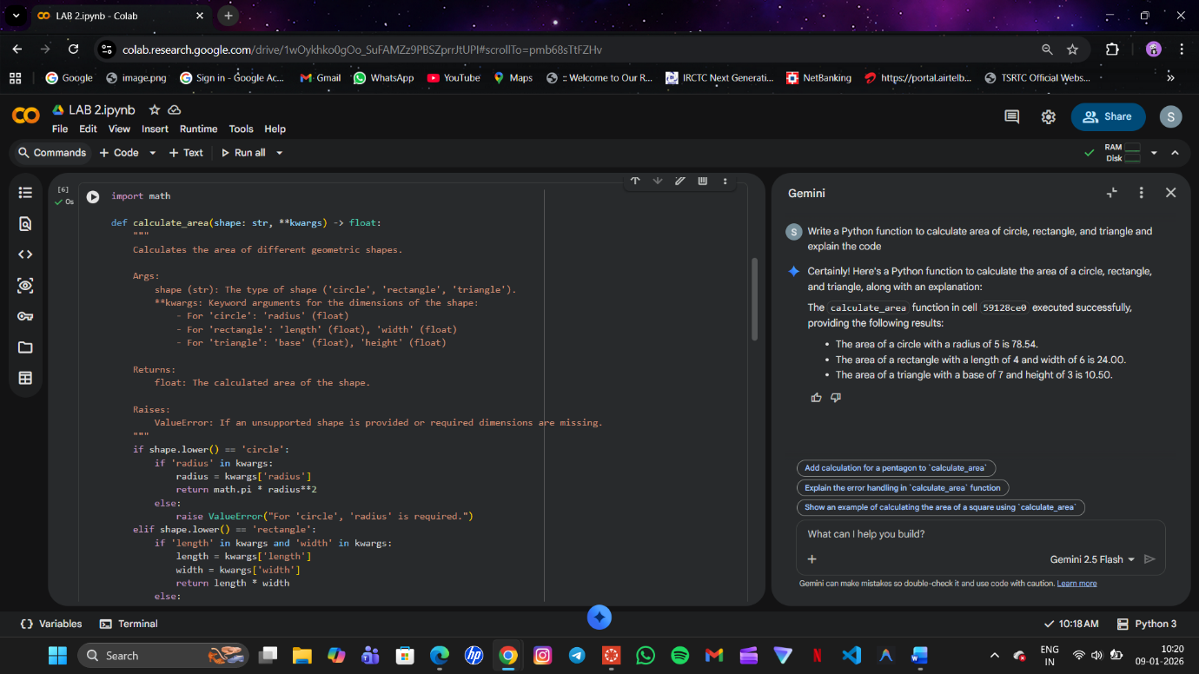
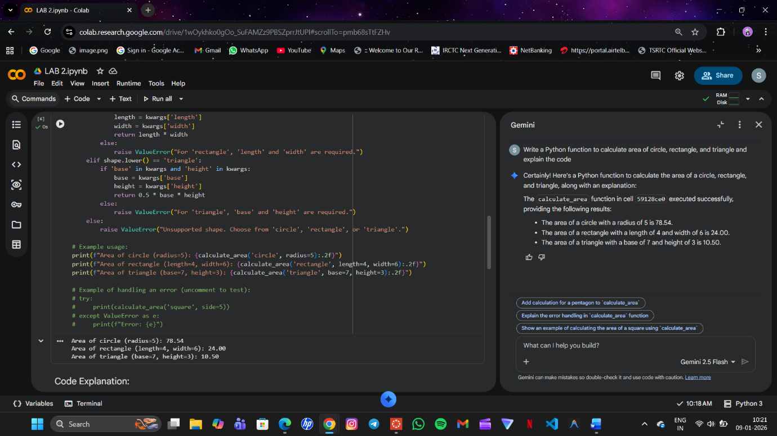
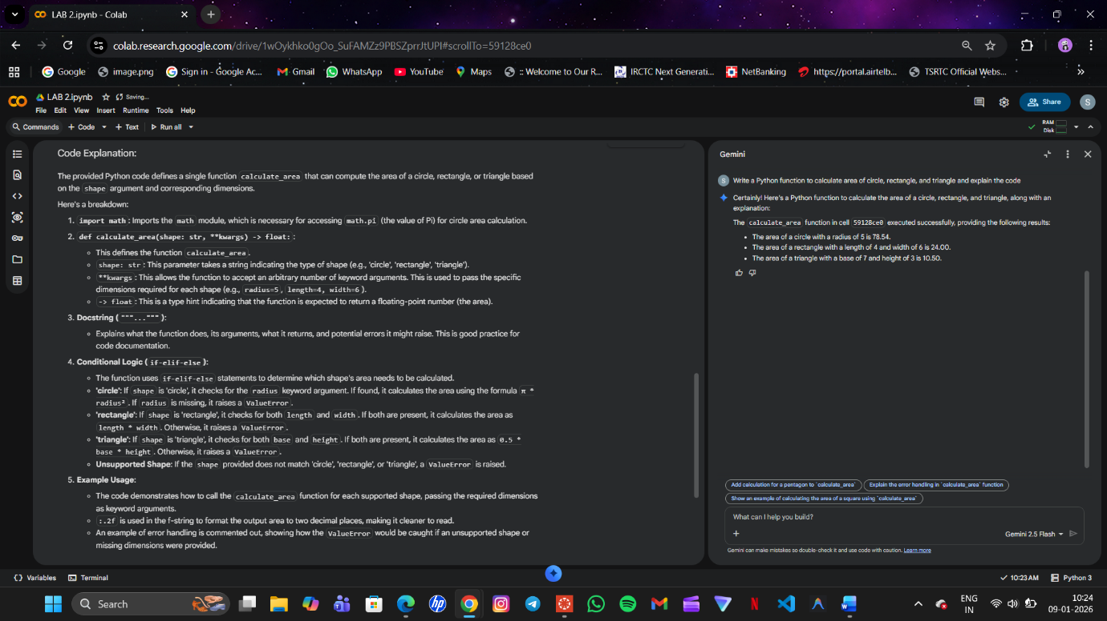
Explanation :
The function accepts the shape name and required dimensions as input. Conditional statements decide which formula to apply. For a circle, radius is used, while rectangle and triangle require two values. The function returns the calculated area based on the selected shape.

Task 3: Prompt Sensitivity Experiment (Cursor AI)
Use Cursor AI with different prompts for the same problem and observe
code changes.
The factorial problem was used to test how different prompts affect AI-generated code.
Prompts Used :
1. Write a Python program to calculate factorial
2. Write an optimized Python function to calculate factorial with comments
3. Generate a beginner-friendly factorial program with error handling
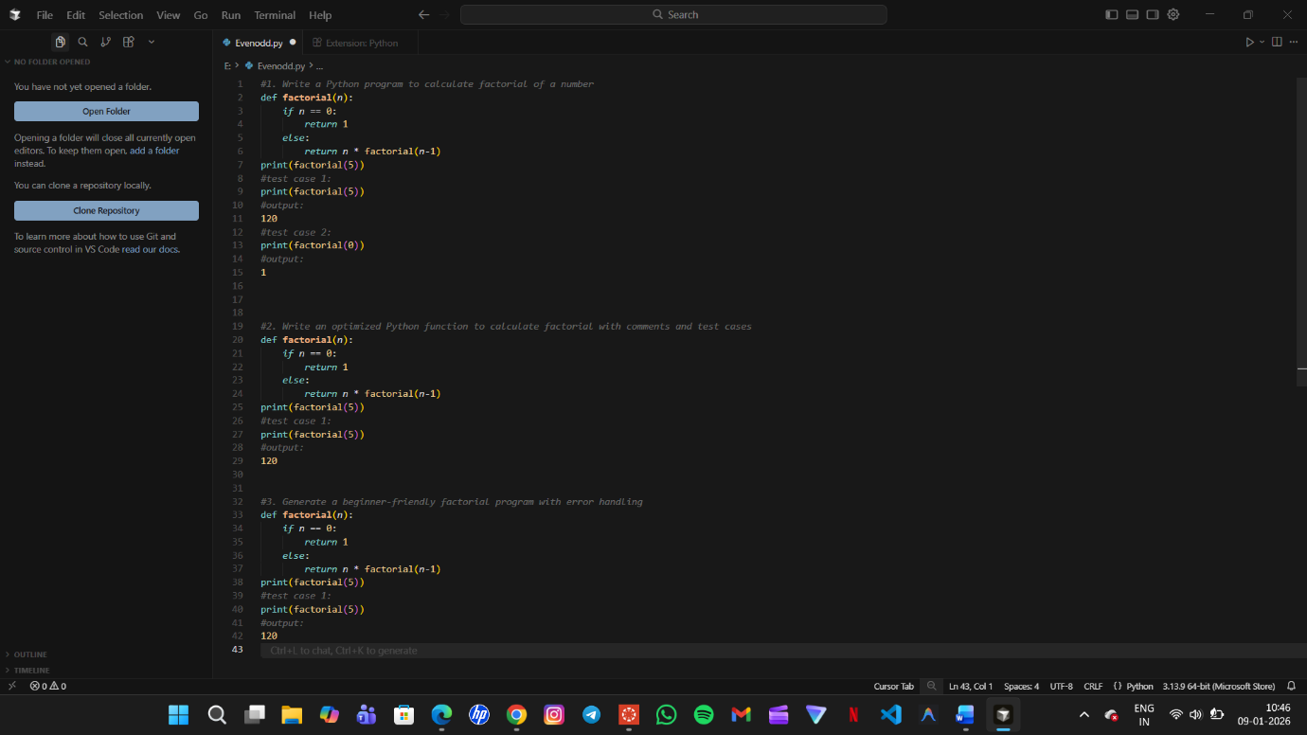
Observation
The AI produced different code styles depending on the prompt. Optimized prompts improved performance and readability, while beginner-friendly prompts added validation and safety checks.
Task 4: Tool Comparison Reflection
Comparison of Gemini, Copilot, and Cursor AI
Reflection :
Google Gemini is best suited for explanations and learning support. GitHub Copilot provides real-time inline suggestions, improving developer productivity. Cursor AI excels in experimentation, refactoring, and prompt-based exploration. Each tool serves a different purpose, and choosing the right one depends on whether the goal is learning, development speed, or code analysis.

